# Persistent Identifiers: A Quick Primer & How-To

#### **WHAT ARE PERSISTENT IDENTIFIERS?**

Persistent identifiers are stable references, often to digital objects, created to maintain access to information for long periods of time.

#### **WHY ARE THEY IMPORTANT?**

Have you ever clicked a website link, only to find yourself on an error page alerting you that what you’re looking for no longer exists? Almost all of us have encountered this problem while on the internet.

Unfortunately, URLs (uniform resource locators, or website links) often deteriorate over time, whether because of website updates, moving files to another location, or other issues. Broken links are sometimes referred to as ‘link rot’ (Persistent identifiers, n.d.), and not only are they annoying, they can prevent you from accessing research and other important sources. This is why persistent identifiers, such as digital object identifiers (DOI), international standard book identifiers (ISBN), and other similar systems have been created.

#### **WHAT MAKES THEM USEFUL?**

While full-length citations are still important for attribution, persistent identifiers are unique, which makes them ideal for conducting known item searches. Including a persistent identifier like a DOI in your references is an easy way to ensure that you (and your instructor) can find your references later. Shorter and more consistent than a citation, inputting a persistent identifier, like a DOI, into a search box should surface exactly what you’re looking for on the first try. Plus, because they’re meant to be permanent, persistent identifiers are more likely to take you to your source than a regular URL hyperlink, especially months or years down the road.

#### **WHY NOT MAKE EVERY LINK A PERSISTENT IDENTIFIER?**

While it would be great if all links were persistent, this is unlikely to happen any time soon. Creating persistent identifiers can be expensive and high-maintenance, so thus, it only makes sense to apply them to publicly available resources (Persistent identifiers, n.d.).

#### **EXAMPLES OF PERSISTENT IDENTIFIERS**

* [DOI](https://www.doi.org/factsheets/DOIKeyFacts.html) → digital object identifier, usually applied to academic journal articles
* [ISBN](https://www.isbn-international.org/content/what-isbn) → international standard book number, usually applied to books
* [ORCID](https://support.orcid.org/hc/en-us/articles/360006897674) → researcher ID, usually applied to authors of academic journal articles
* Permalinks → found on many types of websites, from blogs to library databases

#### **HOW-TO: DOIs**

##### ***How to find a DOI***

Usually, if a journal article has a DOI, you’ll find it in the library catalog entry, in the citation, or somewhere in the article itself.

Example of the DOI listing in a library catalog entry (in UW Libraries, at bottom):

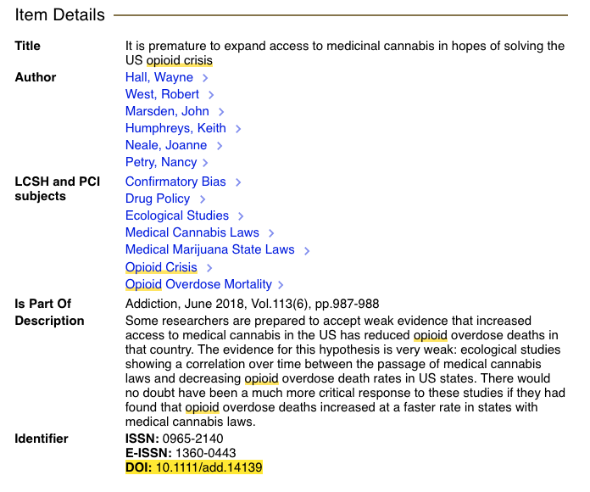

Example of a DOI listing in the citation (in PubMed, to the right):

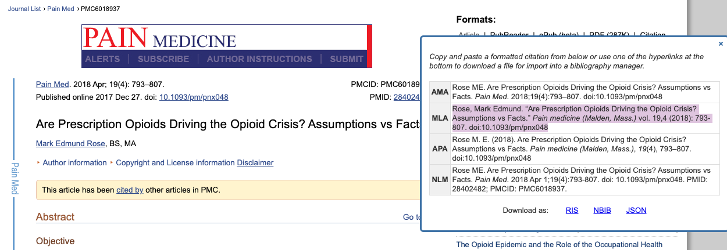

Example of a DOI in the journal article itself (in this case, at the top):



##### ***How to search with a DOI***

Once you know the DOI for a journal article (e.g., in the two articles above, ‘Are Prescription Opioids Driving the Opioid Crisis? Assumptions vs Facts’, it’s doi: 10.1093/pm/pnx048), you can use this to search for your article. In most library databases, all you need is alphanumeric string -- in this case, 10.1093/pm/pnx048. If you’re googling it, you will likely need to include ‘doi,’ e.g. ‘doi 10.1093/pm/pnx048.’

See this search now in:

* [Seattle Central Library](https://sbctc-seattlecolleges.primo.exlibrisgroup.com/discovery/search?query=any,contains,10.1093~2Fpm~2Fpnx048&tab=Everything&search_scope=MyInst_and_CI&vid=01STATEWA_SEATTLE:CSEATTLE)
* [Google Scholar](https://scholar.google.com/scholar?hl=en&as_sdt=0%2C48&q=10.1093%2Fpm%2Fpnx048&btnG=)
* [Google](https://www.google.com/search?source=hp&ei=5X-2XdVhicj6BIzdjdAC&q=doi+10.1093%2Fpm%2Fpnx048&oq=doi+10.1093%2Fpm%2Fpnx048&gs_l=psy-ab.3...1625.12920..13269...2.0..0.121.243.2j1......0....2j1..gws-wiz.....6..0i362i308i154i357.QBdVcywN1E8&ved=0ahUKEwiV6JDIn77lAhUJpJ4KHYxuAyoQ4dUDCAg&uact=5)

##### ***How to cite a DOI***

APA recommends the inclusion of a DOI over a regular ‘retrieved from’ link whenever possible, because it’s more persistent (Reference List, n.d.). If a DOI exists for the article, you should include it at the end of the citation, as either doi:0000000/000000000000 or <https://doi.org/10.0000/0000>.

Example:

Rose, M. E. (2017). Are prescription opioids driving the opioid crisis? Assumptions vs facts.

*Pain Medicine*, *19*(4), 793-80. doi:10.1093/pm/pnx048

#### **REFERENCES**

Persistent identifiers: Working level. (n.d.) Retrieved from

<https://www.ands.org.au/guides/persistent-identifiers-working>.

## Reference List: Electronic Sources (Web Publications). (n.d.). Retrieved from <https://owl.purdue.edu/owl/research_and_citation/apa_style/apa_formatting_and_style_guide/reference_list_electronic_sources.html>.